Tiny Swans: Growing Together CIC
Brunch Club Registration Form
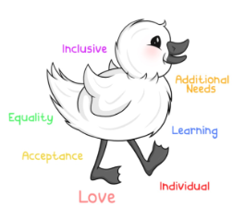
Child’s Name |  | Date Of Birth
Parent/  Guardian Name 1 |  | Contact Number
Parent/  Guardian Name 2 |  | Contact Number
Home Address
E-Mail
Emergency Contact  Name |  | Contact Number
Does your child have any allergies? If so, please specify: |  | Yes / No
What food/snacks does your child enjoy for breakfast and lunch?

Is there anything else you wish for us to know about your child?

Do you give consent for staff to administer Calpol in an emergency? |  | Yes / No
Do you give consent for your child to be photographed and the photos posted on Tiny Swans CIC’s social media/website? |  | Yes / No
Estimated date of Flying Start or Formal School Start:

I would like my child to attend Brunch Club on the following mornings:
Monday | Tuesday | Thursday

Payment Contract
- Each session costs £10.00.
- Please inform us if you are on Universal Credit and we can offer a reduced rate. (These spaces are limited).
- Fees are to be paid two weeks in advance. If you fail to do this, a late payment fee of £2 will apply.
- Any absences (sick days and holidays) are to be paid in full.
- Two weeks’ paid notice is now required when you no longer want your child’s place.

Other Requirements
- Children’s bags cannot contain food or drink unless special arrangements are made. Please only provide a change of clothes, nappies and wet wipes. Food and drink will be provided for the children.
- You give us permission to use alcohol gel unless special arrangements are made.
- On sunny days you will apply sun cream and a hat yourselves before your child’s session.

I agree to the above contracts, terms and conditions.
Signed |  | Date


